BASAVARAJESWARI GROUP OF INSTITUTIONS
Ballari Institute of Technology & Management
AUTONOMOUS INSTITUTE UNDER VISVESVARAYA TECHNOLOGICAL UNIVERSITYJNANA SANGAMA,

Report On

STAKEHOLDER COMMUNICATION PLATFORM
Submitted in partial fulfillment of the requirements for the award of degree of
Bachelor of Engineering
In
ARTIFICIAL INTELLITIFICIAL INTELLGENCE
AND MACHINE LEARNING
Submitted by
P. MANOGNYA - 3BR23AI116
SOWJANYA .N - 3BR23AI153
PALAK YADAV - 3BR23AI116
SAFINA FATHIMA - 3BR23AI139
SP.MANISHA - 3BR23AI136
Internship Carried Out
By
EZ TRAININGS & TECHNOLOGIES PVT.LTD
HYDERABAD
Internal Guide
External Guide S.STEFFI NIVEDITA Bhavna Vaishnav
Asst.prof,CSE Technical Trainer
VARADA ALEKHYA
Asst. prof,CSE
BALLARI INSTITUTE OF TECHNOLOGY & MANAGEMENT
NACC Accredited Institution*
(Recognized by Govt. of Karnataka, approved by AICTE, New Delhi & Affiliated to
Visvesvaraya Technological University, Belagavi)
"Jnana Gangotri" Campus, No.873/2, Ballari-Hospet Road, Allipur,
Ballar1-583 104 (Karnataka) (India)
Ph: 08392 – 237100 / 237190, Fax: 08392 – 237197
2023-2024

BALLARI INSTITUTE OF TECHNOLOGY & MANAGEMENT
NACC Accredited Institution*
(Recognized by Govt. of Karnataka, approved by AICTE, New Delhi & Affiliated to
Visvesvaraya Technological University, Belagavi)
"Jnana Gangotri" Campus, No.873/2, Ballari-Hospet Road, Allipur,
Ballar1-583 104 (Karnataka) (India)
Ph: 08392 – 237100 / 237190, Fax: 08392 – 237197
2023-2024

BELAGAVI 590018

INTERNSHIP

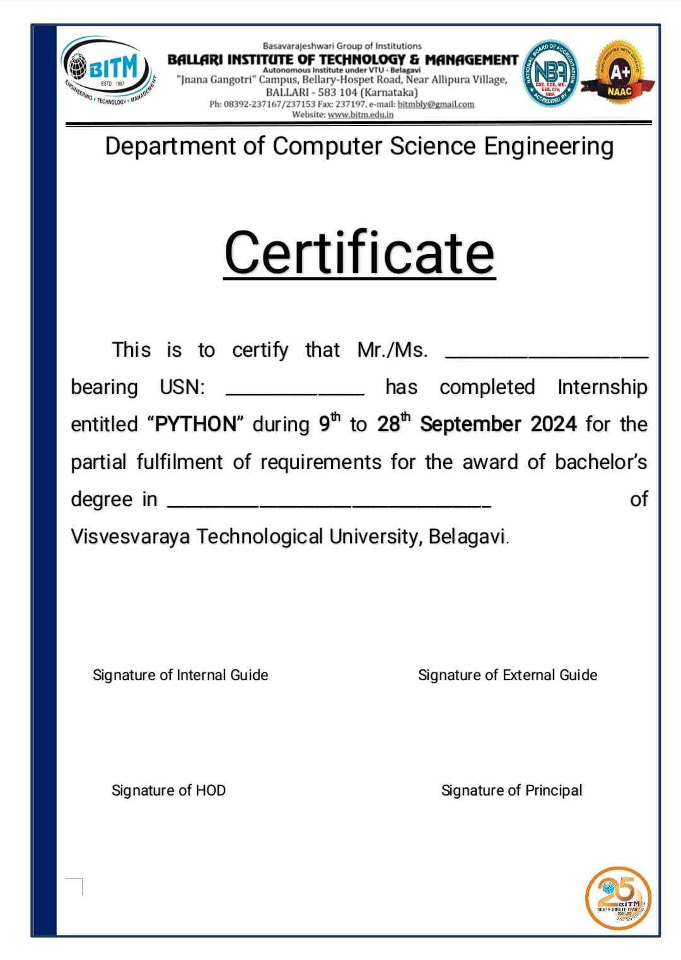

BASAVARAJESWARI GROUP OF INSTITUTIONS
BALLARI INSTITUTE OF TECHNOLOGY & MANAGEMENT
Autonomous institute under VISVESVARAYA TECHNOLOGICAL UNIVERSITYJNANA SANGAMA,
BELAGAVI 590018
NACC Accredited Institution*
(Recognized by Govt. of Karnataka, approved by AICTE, New Delhi & Affiliated to
Visvesvaraya Technological University, Belagavi)
"JnanaGangotri"Campus,No.873/2,Ballari-HospetRoad,Allipur,
Ballar1-583 104 (Karnataka)(India)
Ph: 08392 – 237100 / 237190, Fax: 08392 –237197

DEPARTMENT OF ARITIFICIAL INTELLIGENCE AND
MACHINE LEARNING
CERTIFICATE
This is to certify that the Internship entitled “ STAKEHOLDER COMMUNICATION PLATFORM ” has been successfully completed by P.Manognya-3BR23AI112, Sowjanya.N-3BR23AI153, Palak Yadav-3BR23AI116, Safina Fathima-3BR23AI139, SP.Manisha-3BR23AI136 a bonafide student of Ballari Institute of Technology and Management,
Ballari. For the partial fulfillment of the requirementsfor the Bachelor’s Degree in Artificial Intelligence and Machine Learning of the VISVESVARAYA TECHNOLOGICAL UNIVERSITY, Belagavi during the academic year 2024-2025.

Signature of Internship Co-ordinator Signature of HOD
S.STEFFI NIVEDITA R N KULKARNI
Asst.prof,CSE Prof. and HOD(CSE)
VARADA ALEKHYA Asst. prof,CSE

DECLARATION

P.manognya, Sowjanya.N, Palak Yadav, Safina Fathima, Sp.Manisha second year student of Artificial Intelligence and Machine learning and Engineering, Ballari Institute of Technology, Ballari, declare that Internship entitled STAKEHOLDER COMMUNICATION PLATFORM is a part of Internship Training successfully carried out by EZ TECHNOLOGIES & TRAININGS PVT.LTD ,Hyderabad at “BITM,BALLARI”. This report is submitted in partial fulfillment of the requirements for the award of the degree, Bachelor of Engineering in Computer Science and Engineering of the Visvesvaraya Technological University, Belagavi.

Date : 28 sept 2024 Signature of the Student :

ACKNOWLEDGEMENT

The satisfactions that a company the successful completion of my internship on “ STAKEHOLDER COMMUNICATION PLATFORM ” would be incomplete without the mention of people who made it possible, whose noble gesture, affection, guidance, encouragement and support crowned my efforts with success. It is my privilege to express my gratitude and respect to all those who inspired me in the completion of my internship.

I am grateful to our respective coordinator “Dr. Mallikarjuna A (Asst.prof,AIML) for his noble gesture, support co-ordination and valuable suggestions given to me in the completion of Internship

I also thank Vidyavathi, H.O.D. Department of Artificial Intelligience and Machine Learning for
extending all his valuable support and encouragement.

TABLE OF CONTENTS

Topic PAGE NO
INTRODUCTION 1
PROBLEM STATEMENT 1-4
OBJECTIVE 5
PROGRAM 6-25
RESULT 26-31
CONCLUSION 32

STAKEHOLDER COMMUNICATION PLATFORM

WHAT IS STAKEHOLDER COMMUNICATION PLATFORM ?
Stakeholder communication platform is a software solution designed to streamline the communication process between stakeholders of a project or organization.

PROBLEM STATEMENT
In many projects or organizations, effective communication between stakeholders can be difficult to manage.

1 Disorganized communication.
2 Lack of real-time tracking.
3 Inefficient feedback process.

- DISORGANIZED COMMUNICATION:-
Disorganized communication refers to communication that lacks structure,coherence or clarity, leading to confusion or inefficiency, like unclear message.

- LACK OF REAL-TIME TRACKING:-
Lack of real-time tracking refers to the inability to monitor and update communication activities,decisions, or tasks as they happen.
This can lead to several issues such as:
- Delayed updates
- Missed Deadlines

- INEFFICIENT FEEDBACK PROCESS:-
Inefficient feedback process refers to a feedback mechanism that is slow, unclear, or ineffective.
This can lead to several challenges:
- Delayed Feedback
- Unclear Feedback

HOW THE STAKEHOLDER COMMUNICATION PLATFORM HELPS?
A stakeholder communication platform helps to :-
1 Organized communication.
2 Real-time tracking.
3 Efficient feedback process.

- ORGANIZED COMMUNICATION:-
Organized communication is essential for clarity, transparency, and proper engagement among all parties.

- LACK OF REAL-TIME TRACKING:-
Lack of real-time tracking ensures that all stakeholders have up to date information, helping maintain alignment, improve callobration, and reduce errors in communication.

- EFFICIENT FEEDBACK PROCESS:-
Efficient feedback process allow for timely, clear, and structured communication, with opportunities for discussion and follow-up to ensure continous improvement and alignment among stakeholders

OBJECTIVE
The objective of a stakeholder communication platform is to facillitate effective and efficient communication among stakeholders involved in a project, organization.

import datetime

print("Welcome To Stakeholder Communication Platform!")
print("")

class User:
def _init_(self, user_id, username, password, email, role):
self.user_id = user_id
self.username = username
self.password = password
self.email = email
self.role = role

def change_password(self, new_password):
self.password = new_password

def _repr_(self):
return f"User(ID: {self.user_id}, Username: {self.username}, Email: {self.email}, Role: {self.role})"

class UserManager:
def _init_(self):
self.users = {}

def create_user(self, user_id, username, password, email, role):
if user_id in self.users:
print("User ID already exists!")
else:
self.users[user_id] = User(user_id, username, password, email, role)
print(f"User {username} created successfully!")

def read_user(self, user_id):
user = self.users.get(user_id)
if user:
print(user)
else:
print("User not found!")

def update_user(self, user_id, username=None, password=None, email=None, role=None):
user = self.users.get(user_id)
if user:
if username:
user.username = username
if password:
user.change_password(password)
if email:
user.email = email
if role:
user.role = role
print(f"User {user_id} updated successfully!")
else:
print("User not found!")

def delete_user(self, user_id):
if user_id in self.users:
del self.users[user_id]
print(f"User {user_id} deleted successfully!")
else:
print("User not found!")

class CommunicationLog:
def _init_(self):
self.logs = {}

def create_log(self, log_id, stakeholder_id, communication_type, date):
if log_id in self.logs:
print("Log ID already exists!")
else:
self.logs[log_id] = {
'stakeholder_id': stakeholder_id,
'communication_type': communication_type,
'date': date,
}
print(f"Communication log {log_id} created successfully!")

def read_log(self, log_id):
log = self.logs.get(log_id)
if log:
print(f"Log: Log ID: {log_id}, Communication Type: {log['communication_type']}, Date: {log['date']}")
else:
print("Log not found!")

def update_log(self, log_id, communication_type=None, date=None):
log = self.logs.get(log_id)
if log:
if communication_type:
log['communication_type'] = communication_type
if date:
log['date'] = date
print(f"Log {log_id} updated successfully!")
else:
print("Log not found!")

def delete_log(self, log_id):
if log_id in self.logs:
del self.logs[log_id]
print(f"Log {log_id} deleted successfully!")
else:
print("Log not found!")

class Stakeholder:
def _init_(self, stakeholder_id, name, email):
self.stakeholder_id = stakeholder_id
self.name = name
self.email = email
self.feedback = []

class Feedback:
def _init_(self, feedback_id, stakeholder_id, date, feedback_message):
self.feedback_id = feedback_id
self.stakeholder_id = stakeholder_id
self.date = date
self.feedback_message = feedback_message

class Task:
def _init_(self, name, schedule, status, purpose):
self.name = name
self.schedule = schedule
self.status = status
self.purpose = purpose

def _str_(self):
return f"Task: {self.name}\nSchedule: {self.schedule}\nStatus: {self.status}\nPurpose: {self.purpose}"

class ScheduleManager:
def _init_(self):
self.tasks = []

def add_task(self):
name = input("Enter task name: ")
schedule = input("Enter task schedule (YYYY-MM-DD): ")
status = input("Enter task status: ")
purpose = input("Enter task purpose: ")
new_task = Task(name, schedule, status, purpose)
self.tasks.append(new_task)
print("Task added successfully!\n")

def view_tasks(self):
if not self.tasks:
print("No tasks available.\n")
return
for i, task in enumerate(self.tasks):
print(f"Task {i + 1}:\n{task}\n")

def update_task(self):
self.view_tasks()
if not self.tasks:
return
try:
task_index = int(input("Enter the task number to update: ")) - 1
if 0 <= task_index < len(self.tasks):
schedule = input("Enter new schedule (leave blank to keep current): ")
status = input("Enter new status (leave blank to keep current): ")
purpose = input("Enter new purpose (leave blank to keep current): ")

if schedule:
self.tasks[task_index].schedule = schedule
if status:
self.tasks[task_index].status = status
if purpose:
self.tasks[task_index].purpose = purpose

print("Task updated successfully!\n")
else:
print("Invalid task number.\n")
except ValueError:
print("Please enter a valid number.\n")

class StakeholderCommunicationPlatform:
def _init_(self):
self.logs = CommunicationLog()
self.feedback_list = []
self.stakeholders = {} # Store stakeholders

def add_feedback(self, stakeholder_id, feedback_message):
feedback_id = len(self.feedback_list) + 1
date = datetime.date.today().isoformat()
feedback = Feedback(feedback_id, stakeholder_id, date, feedback_message)
self.feedback_list.append(feedback)
print("Feedback added successfully!")

def read_feedback(self, stakeholder_id):
for feedback in self.feedback_list:
if feedback.stakeholder_id == stakeholder_id:
print(f"Feedback ID: {feedback.feedback_id}, Date: {feedback.date}, Message: {feedback.feedback_message}")
print("End of feedback.")

def analyze_communication_effectiveness(self, stakeholder_id):
# Analyze logs for a specific stakeholder
total_logs = 0
communication_types = {}
for log in self.logs.logs.values():
if log['stakeholder_id'] == stakeholder_id:
total_logs += 1
communication_type = log['communication_type']
communication_types[communication_type] = communication_types.get(communication_type, 0) + 1

if total_logs == 0:
print(f"No communication logs found for Stakeholder ID: {stakeholder_id}.")
return

print(f"Communication Analysis for Stakeholder ID: {stakeholder_id}")
print(f"Total Communications: {total_logs}")
for comm_type, count in communication_types.items():
print(f"{comm_type.capitalize()}: {count} ({(count / total_logs) * 100:.2f}%)")

def main_menu():
platform = StakeholderCommunicationPlatform()
user_manager = UserManager()
schedule_manager = ScheduleManager()

while True:
print("\nWelcome To Stakeholder Communication Platform!")
print("1. Stakeholder Details")
print("2. Communication Log")
print("3. Feedback")
print("4. Schedule")
print("5. Communication Analysis")
print("6. Exit")
choice = input("Select an option (1-6): ")

if choice == '1':
while True:
print("\nOptions:")
print("1. Create User")
print("2. Read User")
print("3. Update User")
print("4. Delete User")
print("5. Change Password")
print("6. Exit")
choice = input("Select an option (1-6): ")
if choice == '1':
user_id = input("Enter User ID: ")
username = input("Enter Username: ")
password = input("Enter Password: ")
email = input("Enter Email: ")
role = input("Enter Role: ")
user_manager.create_user(user_id, username, password, email, role)
elif choice == '2':
user_id = input("Enter User ID to read: ")
user_manager.read_user(user_id)
elif choice == '3':
user_id = input("Enter User ID to update: ")
username = input("Enter new Username (leave blank to skip): ")
password = input("Enter new Password (leave blank to skip): ")
email = input("Enter new Email (leave blank to skip): ")
role = input("Enter new Role (leave blank to skip): ")
user_manager.update_user(user_id, username or None, password or None, email or None, role or None)
elif choice == '4':
user_id = input("Enter User ID to delete: ")
user_manager.delete_user(user_id)
elif choice == '5':
user_id = input("Enter User ID to change password: ")
new_password = input("Enter new Password: ")
user_manager.update_user(user_id, password=new_password)
elif choice == '6':
break
else:
print("Invalid option. Please try again.")

elif choice == '2':
while True:
print("\nCommunication Log Options:")
print("1. Create Log")
print("2. Read Log")
print("3. Update Log")
print("4. Delete Log")
print("5. Exit")
log_choice = input("Select an option: ")
if log_choice == '1':
log_id = input("Enter Log ID: ")
stakeholder_id = input("Enter Stakeholder ID: ")
communication_type = input("Enter Communication type (email/phone/text): ")
date = input("Enter Date of communication (YYYY-MM-DD): ")
platform.logs.create_log(log_id, stakeholder_id, communication_type, date)
elif log_choice == '2':
log_id = input("Enter Log ID to read: ")
platform.logs.read_log(log_id)
elif log_choice == '3':
log_id = input("Enter Log ID: ")
communication_type = input("Enter new Communication type (leave blank to skip): ")
date = input("Enter new Date (leave blank to skip): ")
platform.logs.update_log(log_id, communication_type or None, date or None)
elif log_choice == '4':
log_id = input("Enter Log ID to delete: ")
platform.logs.delete_log(log_id)
elif log_choice == '5':
break
else:
print("Invalid option. Please try again.")

elif choice == '3':
while True:
print("\nFeedback Options:")
print("1. Add Feedback")
print("2. Read Feedback")
print("3. Exit")
feedback_choice = input("Select an option: ")
if feedback_choice == '1':
stakeholder_id = input("Enter Stakeholder ID: ")
feedback_message = input("Enter Feedback Message: ")
platform.add_feedback(stakeholder_id, feedback_message)
elif feedback_choice == '2':
stakeholder_id = input("Enter Stakeholder ID to read feedback: ")
platform.read_feedback(stakeholder_id)
elif feedback_choice == '3':
break
else:
print("Invalid option. Please try again.")

elif choice == '4':
while True:
print("\nSchedule Options:")
print("1. Add Task")
print("2. View Tasks")
print("3. Update Task")
print("4. Exit")
schedule_choice = input("Select an option: ")
if schedule_choice == '1':
schedule_manager.add_task()
elif schedule_choice == '2':
schedule_manager.view_tasks()
elif schedule_choice == '3':
schedule_manager.update_task()
elif schedule_choice == '4':
break
else:
print("Invalid option. Please try again.")

elif choice == '5':
stakeholder_id = input("Enter Stakeholder ID to analyze: ")
platform.analyze_communication_effectiveness(stakeholder_id)

elif choice == '6':
print("Exiting program.")
break
else:
print("Invalid option. Please try again.")

if _name_ == "_main_":
main_menu()

print("Thank you!")
print("Visit Again!")

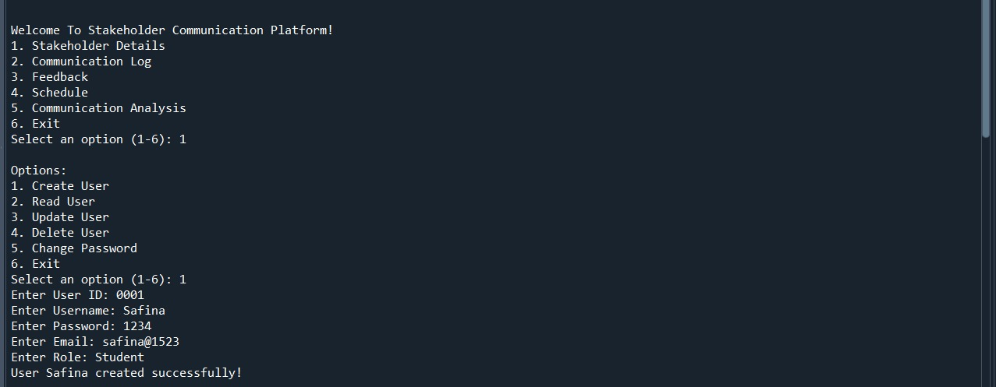

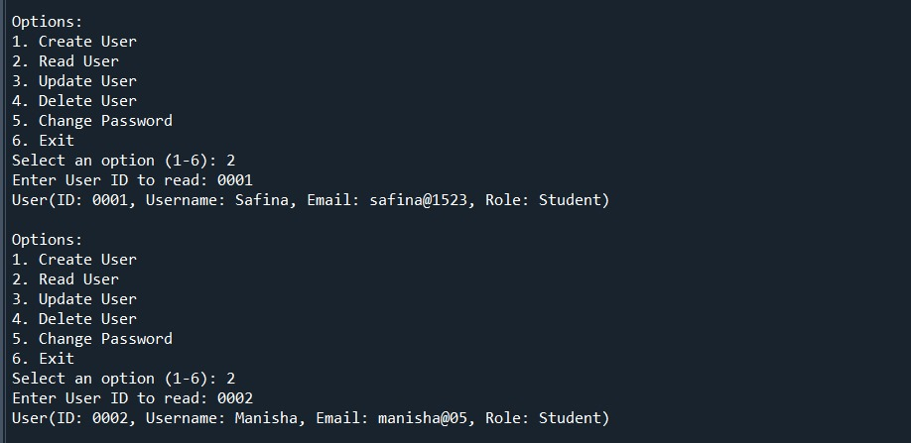

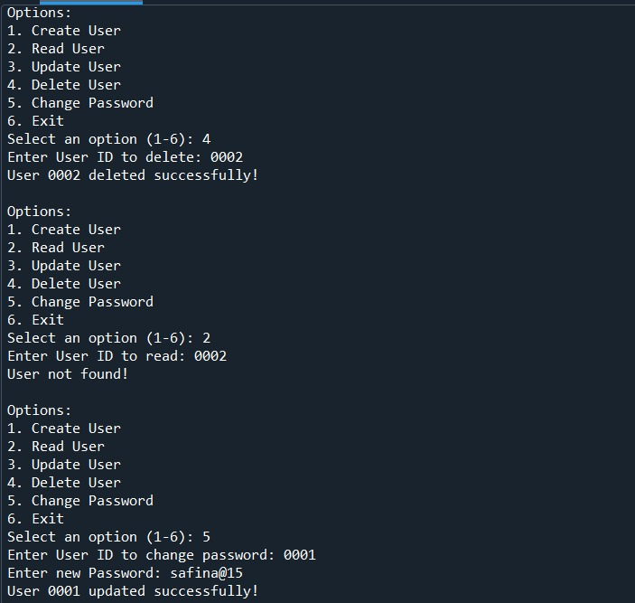

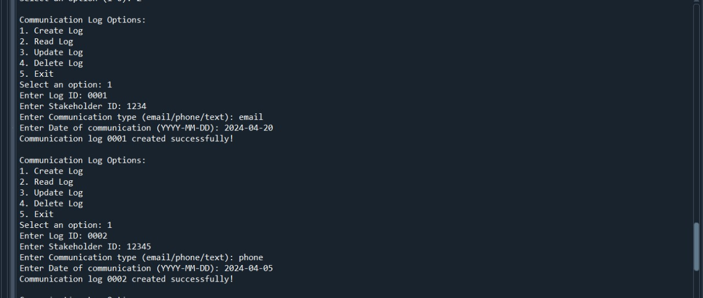
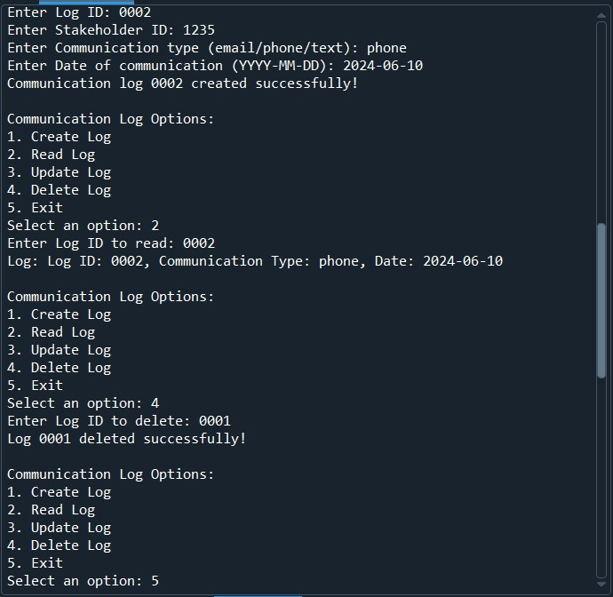
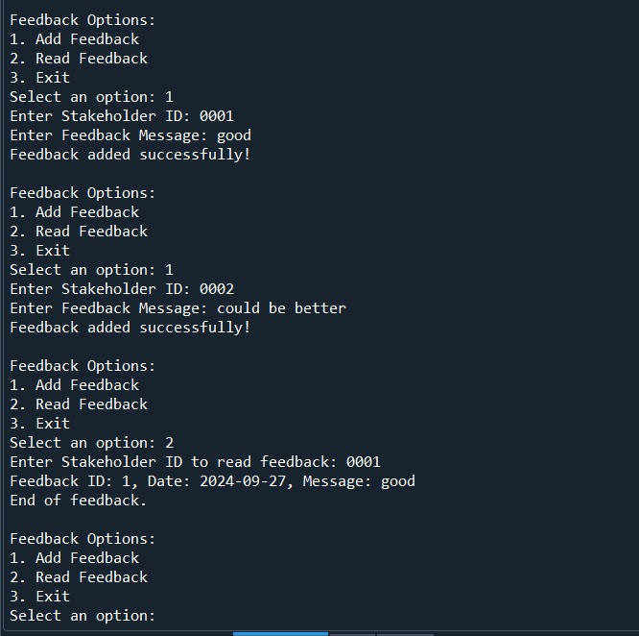

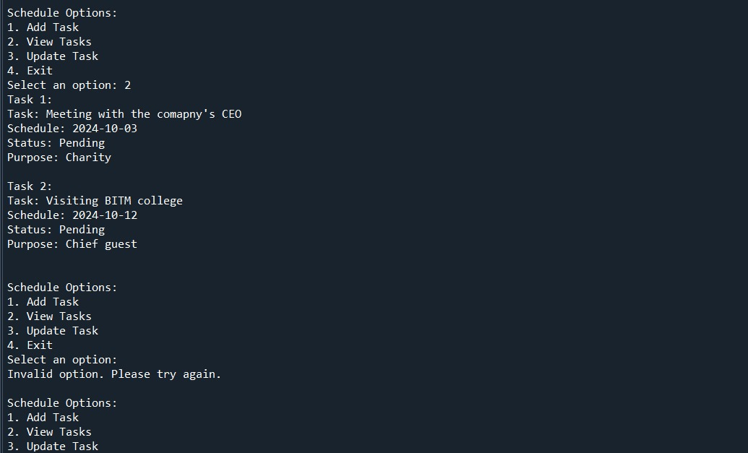

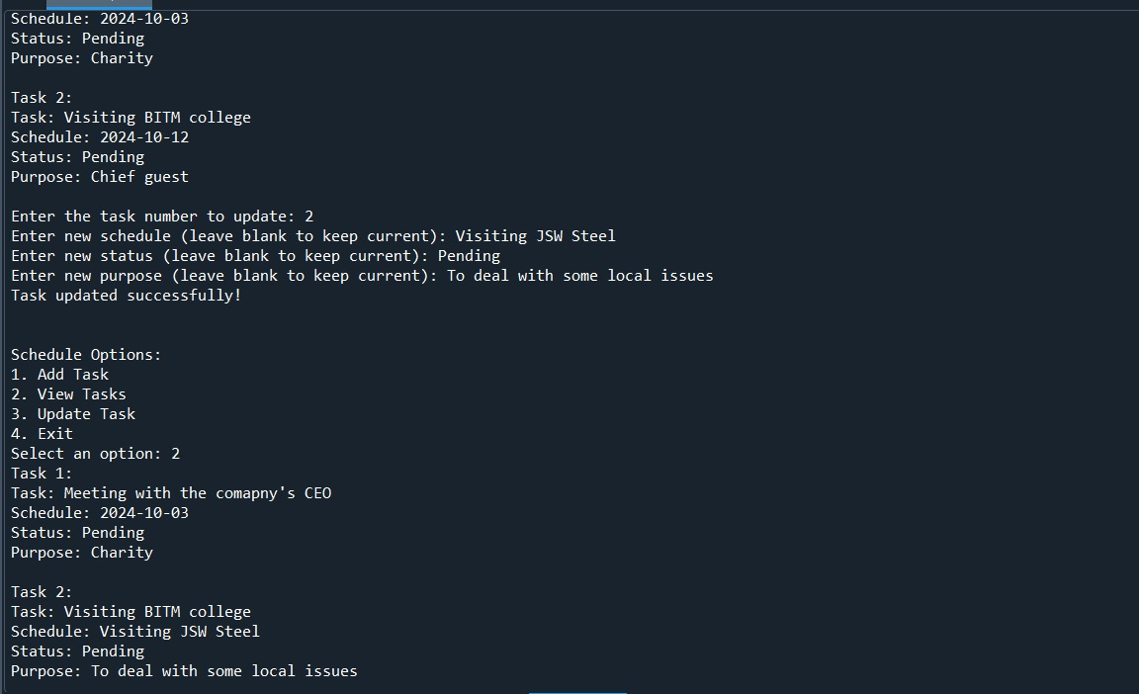

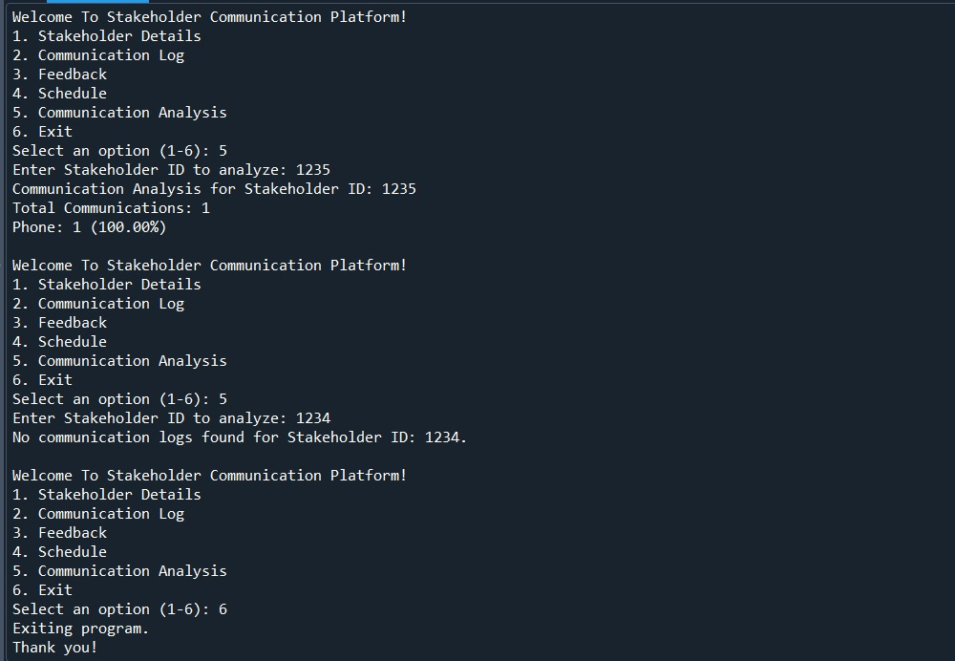

CONCLUSION
A stakeholder communication platform is essential for improving how stakeholders connect and work together.

This transparency builts trust,supports better decision-making.

It strengthens relationships among stakeholders and contributes to the success of projects.

